HTML (Hypertext Markup Language) is the standard markup language used to create web pages.

It defines the structure of a web page by using markup tags to describe elements such as headings,

paragraphs, images, links, and more.

1. Document Type Declaration (DOCTYPE):

html

Copy code

<!DOCTYPE html>

The DOCTYPE declaration is used to inform the web browser about the version of HTML being used.

In this case, it declares that the document is written in HTML5.

2. HTML Element:

html

Copy code

<html>

//main content this

</html>

The <html> element wraps the entire content of the web page.

It serves as the root element and contains all other elements of the HTML document.

3. Head Element:

html

Copy code

<head>

<!-- Metadata and external resources go here -->

<title>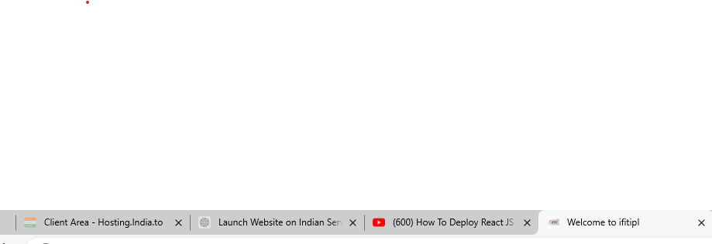

</title>

</head>

The <head> element contains metadata about the document, such as the page title, character encoding, CSS stylesheets, JavaScript files, and other resources. It doesn't display any visible content on the web page itself.

4. Title Element:

html

Copy code

<title>My First Web Page</title>

The <title> element specifies the title of the web page, which appears in the browser's title bar or tab. It's also used by search engines for indexing purposes.

5. Body Element:

html

Copy code

<body>

Entire website design code should be placed inside the body tag, and only the content within the body tag.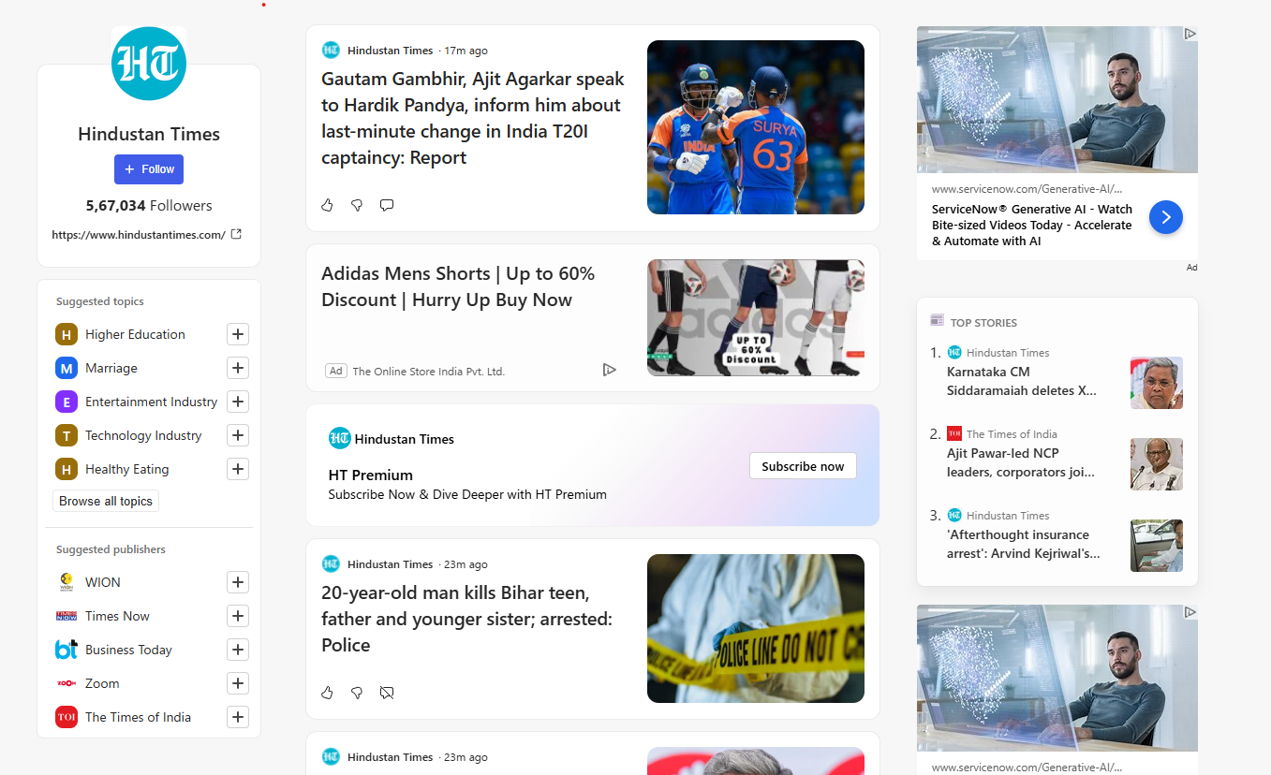

</body>

The <body> element contains the main content of the web page, including text, images, links, forms, and other elements that users interact with. It's where you put everything that you want to be displayed on the web page.

Putting it all together, a basic HTML structure looks like this:

html

Copy code

<!DOCTYPE html>

<html>

<head>   
<title>My First Web Page</title>

</head>

<body>

<!-- Content goes here -->

</body>  
</html> output:  
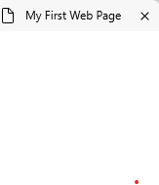

----------------------------------------

Common HTML Tags ---

------------------------------------------

HTML tags are fundamental building blocks used to create the structure and content of a web page.

They define various elements such as headings, paragraphs, links, images, lists, and more.

Here's an explanation of some of the most commonly used HTML tags:

Headings (<h1> to <h6>):

Headings are used to define the hierarchy and importance of text on a web page.

<h1> is the highest level heading, while <h6> is the lowest.

html

Copy code

<h1>This is a Heading 1</h1>

<h2>This is a Heading 2</h2>

<!-- and so on until h6 -->

Paragraphs (<p>): [W3Schooxls Tryit Editor](https://www.w3schools.com/html/tryit.asp?filename=tryhtml_editors)

Paragraph tags are used to define paragraphs of text.

html

Copy code

<p>This is a paragraph of text.</p>

Anchor (<a>): [W3Schools Tryit Editor](https://www.w3schools.com/html/tryit.asp?filename=tryhtml_attributes_link)

Anchor tags are used to create hyperlinks to other web pages or resources.

html

Copy code

<a href="ht ntps://www.example.com">Visit Example</a>

Image (<img>): [W3Schools Tryit Editor](https://www.w3schools.com/html/tryit.asp?filename=tryhtml_attributes_img_src)

Image tags are used to embed images on a web page.

html

Copy code

<img src="image.jpg" alt="Description of image">[W3Schools Tryit Editor](https://www.w3schools.com/html/tryit.asp?filename=tryhtml_attributes_img_src)

Unordered List (<ul>) and List Item (<li>):

Unordered lists are used to create bulleted lists, and each list item within <li> tags represents an item in the list.

html

Copy code

<ul>

<li>Item 1</li>

<li>Item 2</li>

<li>Item 3</li>

</ul>

Ordered List (<ol>): ==🡺[W3Schools Tryit Editor](https://www.w3schools.com/html/tryit.asp?filename=tryhtml_lists_unordered2)

Ordered lists are used to create numbered lists.

html

Copy code

<ol>

<li>First Item</li>

<li>Second Item</li>

<li>Third Item</li>

</ol>

Division (<div>) and Span (<span>):[W3Schools Tryit Editor](https://www.w3schools.com/html/tryit.asp?filename=tryhtml_lists_ordered2)

<div> and <span> are generic container elements used to group and style content.

html

Copy code

<div>This is a division.</div>

<span>This is a span.</span>

Bold (<b>),

Italic (<i>):

<b> and <i> tags are used to make text bold and italic, respectively.

html

Copy code

<b>This is bold text.</b>[W3Schools Tryit Editor](https://www.w3schools.com/html/tryit.asp?filename=tryhtml_formatting_b)

<i>This is italic text.</i>[W3Schools Tryit Editor](https://www.w3schools.com/html/tryit.asp?filename=tryhtml_formatting_i)

Line Break (<br>):

The <br> tag is used to insert a line break within text.

html

Copy code

<p>This is the first line.<br>This is the second line.</p>

Horizontal Rule (<hr>):[W3Schools Tryit Editor](https://www.w3schools.com/tags/tryit.asp?filename=tryhtml_hr_test)

The <hr> tag is used to insert a horizontal line (or rule) to separate content.

html

Copy code

<p>Some content above the line</p>

<hr>[W3Schools Tryit Editor](https://www.w3schools.com/tags/tryit.asp?filename=tryhtml_hr_test)

<p>Some content below the line</p>

HTML -- Attributes

-------------------------------------

Depending on the attribute and the element it's used with, attributes can change how an element looks or behaves. For example, the href attribute in a link tag determines where the link takes you when clicked, and the src attribute in an image tag specifies which image to display.

Examples of Attributes: Here are some common attributes:

href: Specifies the URL of the link destination.

src: Specifies the URL of the image to be displayed.

alt: Provides alternative text for images (useful for accessibility).

id: Specifies a unique identifier for an element.

class: Specifies one or more classes for an element (for styling with CSS).

style: Specifies inline CSS styles for an element. [W3Schools Tryit Editor](https://www.w3schools.com/html/tryit.asp?filename=tryhtml_styles_font-size)

HTML Attribute Example: Linking to a Website

Suppose you want to create a link on your web page that takes users to a different website when clicked. Here's how you would do it using HTML attributes:

html

Copy code

<a href="https://www.example.com">Visit Example Website</a>[W3Schools Tryit Editor](https://www.w3schools.com/html/tryit.asp?filename=tryhtml_attributes_link)

Let's break it down:

<a>: This is the anchor tag, used to create a link.

href: This is the attribute we're using. It stands for "hypertext reference."

It tells the browser where the link should take the user when clicked.

"https://www.example.com": This is the value of the href attribute.

It's the URL (web address) of the website we want to link to.

Visit Example Website: This is the text that will appear as the clickable link on the web page.

So, when a user clicks on the link "Visit Example Website," the browser will take them to the website

specified in the href attribute, which in this case is "https://www.example.com".

HTML Headings:

--------------------------

HTML headings are used to define the structure and hierarchy of the content on a web page. They range from <h1> to <h6>, with <h1> being the most important and <h6> being the least important.

Example:

Suppose you're creating a web page about different types of fruits, and you want to organize the content with headings.

html

Copy code

<!DOCTYPE html>

<html>

<head>

<title>Fruits Page</title>

</head>

<body>

<h1>Types of Fruits</h1>

<h2>Citrus Fruits</h2>

<p>Oranges, lemons, and limes are all examples of citrus fruits.</p>

<h2>Stone Fruits</h2>

<p>Peaches, plums, and cherries are examples of stone fruits.</p>

<h2>Berries</h2>

<p>Strawberries, blueberries, and raspberries are all types of berries.</p>

</body>

</html>

Explanation: =🡺[W3Schools Tryit Editor](https://www.w3schools.com/html/tryit.asp?filename=tryhtml_paragraphs2)

<h1>Types of Fruits</h1>: This is the main heading of the web page. It gives an overview of what the page is about. <h1> is typically used for the main title or heading of a page.

<h2>Citrus Fruits</h2>: This is a subheading under the main heading. It provides more specific information about a category of fruits. <h2> is used for subheadings that are slightly less important than the main heading.

<h2>Stone Fruits</h2>: Another subheading, this time for a different category of fruits.

<h2>Berries</h2>: Yet another subheading for a different category.

<p>: These are paragraphs of text that provide more details about each type of fruit. They are not headings but regular text content.

HTML Paragraphs:

--------------------------------

In HTML, paragraphs are denoted by the <p> tag.

Example:

Suppose you're creating a webpage about the benefits of exercise. You want to explain each benefit in its own paragraph.

html

Copy code

<!DOCTYPE html>

<html>

<head>

<title>Benefits of Exercise</title>

</head>

<body>

<h1>Benefits of Exercise</h1>

<p>Regular exercise has numerous benefits for both physical and mental health.</p>

<h2>1. Improved Physical Health</h2>

<p>Exercise helps to strengthen muscles, improve cardiovascular health, and increase flexibility.</p>

<h2>2. Weight Management</h2>

<p>Regular physical activity can help maintain a healthy weight by burning calories and boosting metabolism.</p>

<h2>3. Stress Reduction</h2>

<p>Exercise is a great way to reduce stress levels and improve overall mood.</p>

</body>

</html> [W3Schools Tryit Editor](https://www.w3schools.com/html/tryit.asp?filename=tryhtml_paragraphs2)

Explanation:

<p>: The <p> tag is used to create paragraphs of text. Each paragraph is enclosed within these tags.

Example: <p>Regular exercise has numerous benefits for both physical and mental health.</p>

<h2>: In this example, <h2> tags are used to create subheadings for each benefit of exercise. These subheadings provide additional structure to the content and help organize the information.

Example: <h2>1. Improved Physical Health</h2>

Inline Styles:

-------------------------

Inline styles are applied directly to individual HTML elements using the style attribute.

Example:

Suppose you want to make a paragraph text blue and bold:

html

Copy code

<!DOCTYPE html>

<html>

<head>

<title>Inline Styles Example</title>

</head>

<body>

<p style="color: blue; font-weight: bold;">This is a blue and bold paragraph.</p>

</body>

</html>

Explanation:

<p>: This is the paragraph element. [W3Schools Tryit Editor](https://www.w3schools.com/html/tryit.asp?filename=tryhtml_paragraphs2)

style="color: blue; font-weight: bold;": This is the style attribute applied to the paragraph. Inside it, we specify the CSS properties and their values separated by semicolons. Here, we set the text color to blue and the font weight to bold.

External Styles:

External styles are defined in a separate CSS file and linked to the HTML document using the <link> element in the <head> section.

Example:

Suppose you have the following CSS file named "styles.css" with the following content:

css

Copy code

/* styles.css */

p {

color: blue;

font-weight: bold;

} =🡺[W3Schools Tryit Editor](https://www.w3schools.com/Css/tryit.asp?filename=trycss_default)

And your HTML file would look like this:

html

Copy code

<!DOCTYPE html>

<html>

<head>

<title>External Styles Example</title>

<link rel="stylesheet" type="text/css" href="styles.css">

</head>

<body>

<p>This is a blue and bold paragraph.</p>

</body>

</html>

Explanation: [W3Schools Tryit Editor](https://www.w3schools.com/html/tryit.asp?filename=tryhtml_paragraphs2)

p { color: blue; font-weight: bold; }: This is a CSS rule that defines styles for <p> elements. It sets the text color to blue and the font weight to bold.

<link rel="stylesheet" type="text/css" href="styles.css">: This <link> tag in the <head> section links the HTML document to the external CSS file named "styles.css". This allows the HTML document to apply the styles defined in the CSS file to its elements.

Formatting

----------------------

HTML formatting allows you to modify the appearance of text and content on a web page. It includes various elements and attributes that help you control the layout, styling, and presentation of your content. Let's explore some basic HTML formatting options with examples:

1. Bold Text:

You can make text bold using the <strong> or <b> tags.

Example:

html

Copy code

<p>This is <strong>bold</strong> text.</p>[W3Schools Tryit Editor](https://www.w3schools.com/html/tryit.asp?filename=tryhtml_formatting_strong)

2. Italic Text:

Italicize text using the <em> or <i> tags. [W3Schools Tryit Editor](https://www.w3schools.com/html/tryit.asp?filename=tryhtml_formatting_em)

Example:

html

Copy code

<p>This is <em>italic</em> text.</p>[W3Schools Tryit Editor](https://www.w3schools.com/html/tryit.asp?filename=tryhtml_formatting_em)

3. Underlined Text:

Underline text using the <u> tag.

Example:

html

Copy code

<p>This is <u>underlined</u> text.</p> [W3Schools Tryit Editor](https://www.w3schools.com/TAGS/tryit.asp?filename=tryhtml_u)

4. Strikethrough Text:

Apply a strikethrough effect to text using the <s> or <strike> tags.

Example:

html

Copy code

<p>This is <s>strikethrough</s> text.</p>[W3Schools Tryit Editor](https://www.w3schools.com/TAGs/tryit.asp?filename=tryhtml5_s)

5. Subscript and Superscript Text:

Use the <sub> tag for subscript text and the <sup> tag for superscript text.

Example:

html

Copy code

<p>This is H<sub>2</sub>O (water) and E=mc<sup>2</sup> (mass-energy equivalence).</p> [W3Schools Tryit Editor](https://www.w3schools.com/TAGS/tryit.asp?filename=tryhtml_sup)

6. Line Breaks:

Insert line breaks using the <br> tag. [W3Schools Tryit Editor](https://www.w3schools.com/TAGS/tryit.asp?filename=tryhtml_br)

Example:

html

Copy code

<p>This is the first line.<br>This is the second line.</p>[W3Schools Tryit Editor](https://www.w3schools.com/TAGS/tryit.asp?filename=tryhtml_br)

7. Horizontal Rule:

Create a horizontal line using the <hr> tag.

Example:

html

Copy code

<p>This is above the line.</p>

<hr>

<p>This is below the line.</p>

Color :-

---------------------------------

HTML color allows you to specify the colors of text, backgrounds, borders, and other elements on a web page. Colors can be defined using various methods such as color names, hexadecimal codes, RGB values, or HSL values. Let's explore some basic HTML color examples:

1. Color Names:

HTML supports a set of predefined color names, such as "red", "blue", "green", etc.

Example:

html

Copy code

<p style="color: red;">This text is in red.</p>

2. Hexadecimal Codes:

Hexadecimal codes represent colors using a combination of six characters, including numbers (0-9) and letters (A-F). They specify the intensity of red, green, and blue (RGB) components of a color.

Example:

html

Copy code

<p style="color: #ff0000;">This text is in red using hexadecimal code.</p>

3. RGB Values:

RGB values represent colors using combinations of red, green, and blue intensity values ranging from 0 to 255.

Example:

html

Copy code

<p style="color: rgb(255, 0, 0);">This text is in red using RGB values.</p>

4. HSL Values:

HSL (Hue, Saturation, Lightness) values represent colors using hue, saturation, and lightness values.

Example:

html

Copy code

<p style="color: hsl(0, 100%, 50%);">This text is in red using HSL values.</p>

5. Background Color:

You can also set the background color of elements using the background-color property.

Example:

html

Copy code

<p style="background-color: yellow;">This paragraph has a yellow background.</p>

6. Border Color:

You can specify the color of borders using the border-color property.

Example:

html

Copy code

<div style="border: 2px solid blue;">This div has a blue border.</div>

Links

--------------------------------------

HTML links, also known as hyperlinks, allow users to navigate between different web pages or resources on the internet. Links are created using the <a> (anchor) tag in HTML. Here's a breakdown of HTML links with an example:

HTML Links:

In HTML, links are created using the <a> tag, which stands for "anchor."

Example:

Suppose you want to create a link to the OpenAI website:

html

Copy code

<!DOCTYPE html>

<html>

<head>

<title>HTML Links Example</title>

</head>

<body>

<h1>My Website</h1>

<p>Welcome to my website! Click the link below to visit OpenAI's website:</p>

<a href="https://www.openai.com">Visit OpenAI</a>

</body>

</html>

Explanation:

<a>: This is the anchor tag used to create a link.

href: This is the attribute of the <a> tag that specifies the URL (web address) of the destination page or resource. It stands for "hypertext reference."

"https://www.openai.com": This is the value of the href attribute, which is the URL of the OpenAI website.

Visit OpenAI: This is the text that will appear as the clickable link on the web page.

When a user clicks on the link "Visit OpenAI," the browser will navigate to the OpenAI website specified in the href attribute.

Additional Attributes:

HTML links can have additional attributes for various purposes:

target: Specifies where to open the linked document. For example, you can open the link in a new tab using target="_blank".

title: Provides additional information about the link, which is usually displayed as a tooltip when the user hovers over the link.

Example with Additional Attributes:

html

Copy code

<a href="https://www.openai.com" target="_blank" title="Visit OpenAI's Website">Visit Ope

HTML Images:

---------------------------

In HTML, images are inserted using the <img> tag.

Example:

Suppose you have an image file named "example.jpg" in the same directory as your HTML file, and you want to display it on your web page.

html

Copy code

<!DOCTYPE html>

<html>

<head>

<title>HTML Images Example</title>

</head>

<body>

<h1>My Website</h1>

<p>Welcome to my website! Here's an image:</p>

<img src="example.jpg" alt="Example Image">

</body>

</html>

Explanation:

<img>: This is the image tag used to insert an image.

src: This is the attribute of the <img> tag that specifies the URL (source) of the image file. It stands for "source."

"example.jpg": This is the value of the src attribute, which is the file path or URL of the image you want to display.

alt: This is the attribute of the <img> tag that specifies alternative text for the image. It's used for accessibility purposes and is displayed if the image fails to load. It stands for "alternate."

Additional Attributes:

HTML images can have additional attributes for various purposes:

width: Specifies the width of the image in pixels or as a percentage of the containing element's width.

height: Specifies the height of the image in pixels or as a percentage of the containing element's height.

title: Provides additional information about the image, which is usually displayed as a tooltip when the user hovers over the image.

Example with Additional Attributes:

Html full notes pdf:

Html next level referral link: [HTML Tutorial (w3schools.com)](https://www.w3schools.com/html/default.asp), [HTML Tutorial (tutorialspoint.com)](https://www.tutorialspoint.com/html/index.htm), [Learn HTML Tutorial - javatpoint](https://www.javatpoint.com/html-tutorial).